Thermal Energy Puzzle

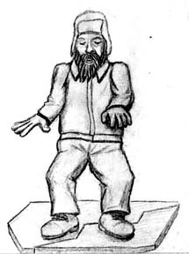
It’s a very cold day in Wisconsin (25 degrees F), and Big John is out ice fishing. He hears the ice crack beneath his feet and he plunges into the icy water!

He manages to drag himself out of the water and to the shore. He will have to walk a mile back to his truck.

Big John remembers a survival show he once saw, where Bear Grylls said you should take off your clothes after falling in cold water.

But John doesn’t have any dry clothes to put on – they’re in his truck.

Should he walk back to his car in his wet clothes, or should he take them all off and walk back naked?

